**Basics & Opening Range Concept**

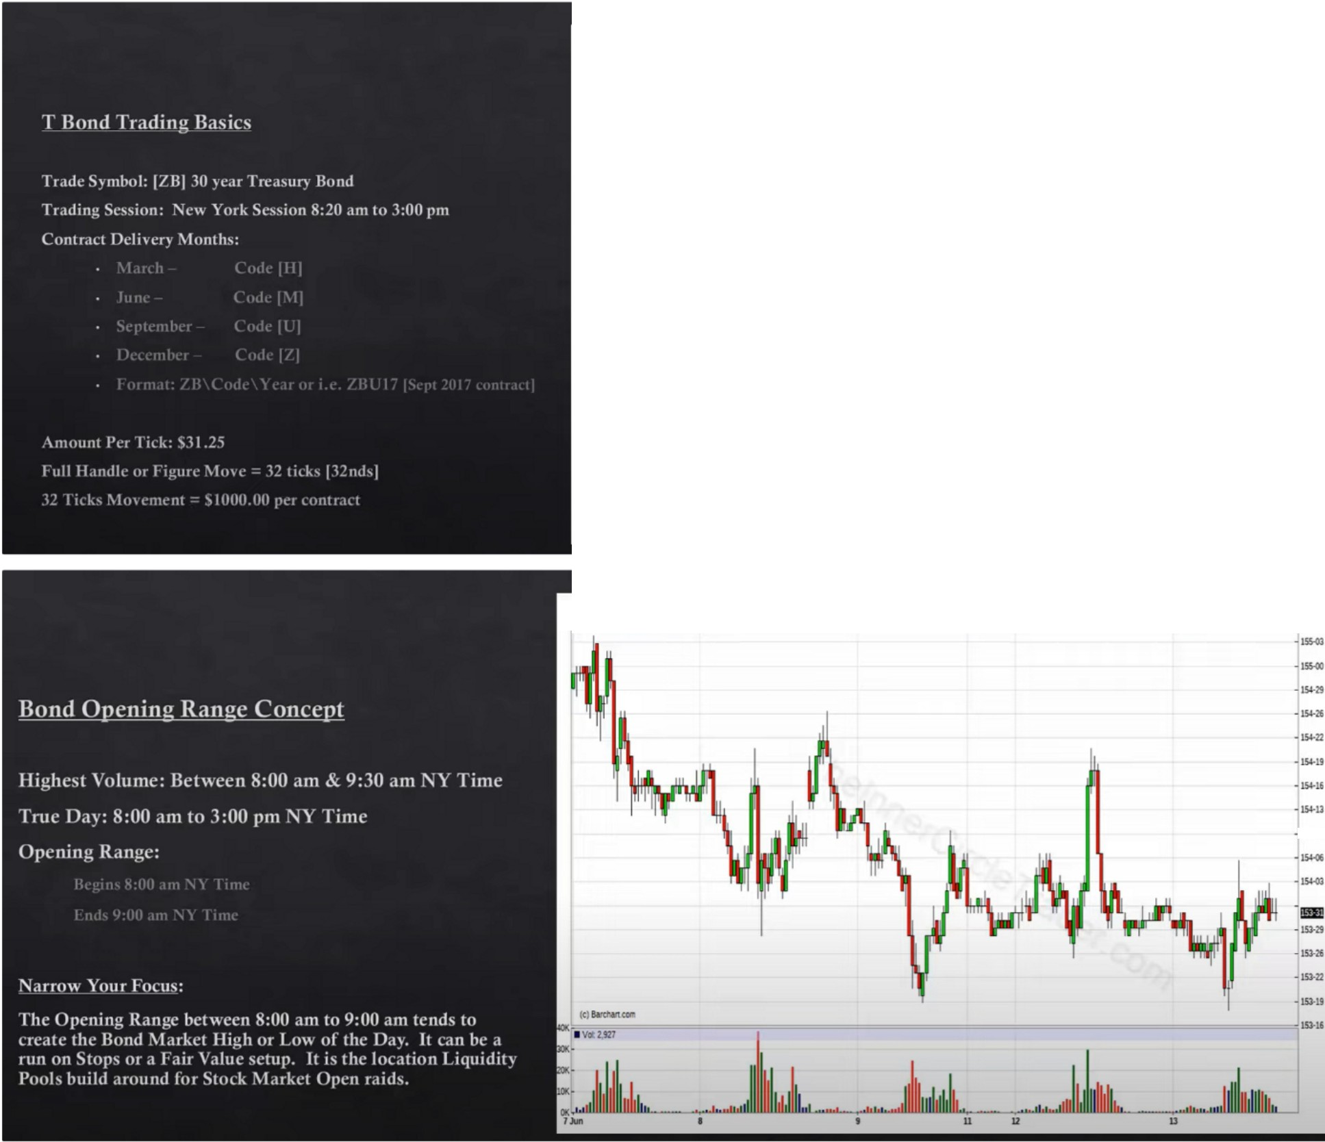

**T-Bond Sep '17 (ZBU17)**

154-01+0·02 (+0.04%)14:58CT [CBOT]

154-00x182 15401 x867

ALL FUTURES CONTRACTS for Tue,Jun 13rd, 2017

Set Alerts * Watchlis

Intraday

¥ Main View

¥

**Z8U17-T&nd-JOMinAttandlesaid:Owt**

* **Op:15,)-ll,lt.15'-«,1.o:W-lO.CllS)-U**

-

....

-;=.'"=-

**L.**

**l\,i..,**

**..**

.,

,

**-,--- b!b,!o.!!• !1-,...**

|  |  |  |  |  |  |  |
| --- | --- | --- | --- | --- | --- | --- |
|  | Contract | Last | Change | Open | High | Low |
| + | ZBM17 Oun '17) | 155-07 | ·0-02 | 155·11 | 155-11 | 154-29 |
| + | ZBU17 (Sep'17) | 154-01 | * 0-02 | 153-30 | 154-06 | 153-18 |
| + | ZBZ17 (Dec '17) | 153-10 | * 0-02 | 0-00 | 153-10 | 153-10 |

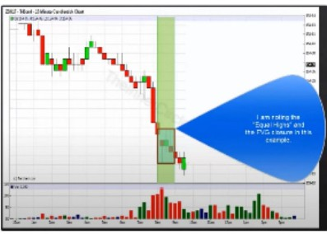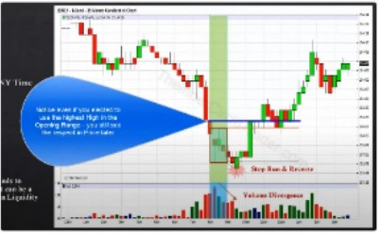

-

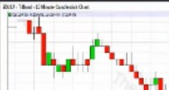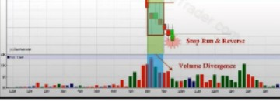

Stop run and potential reversal

Notice how the highest volume of the day is between 8 am and 9 am, and notice also that after that there wasnt a lot of volume, meaning that they already bouth at 8am

Price making a lower low that lower low shouldve been met with a higher bar on volume, that didnt happen so we have a volume divergence. This is a sign of weakness for the downmoves

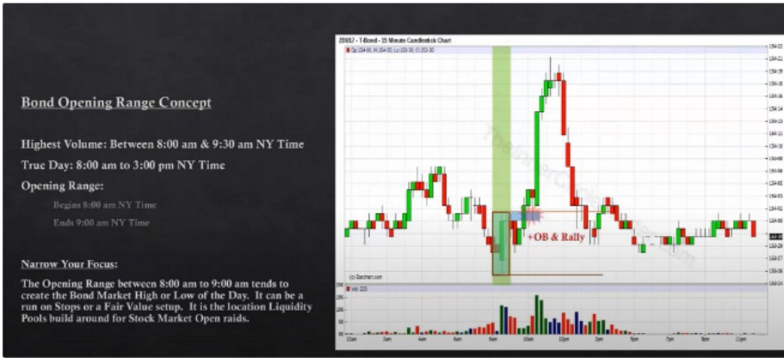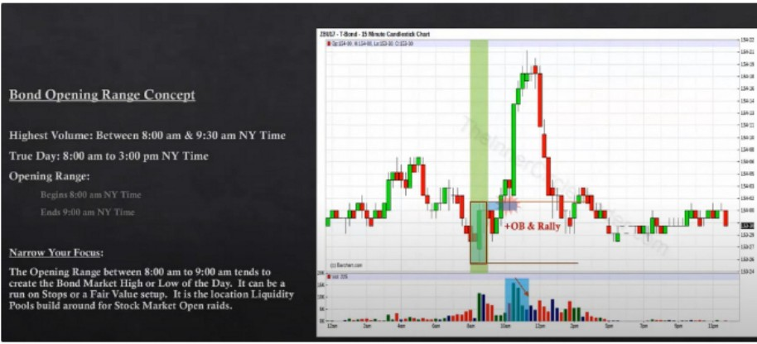

Volume divergene, early sign that the rally was a weak move. Ideally volume shouldve had a higer bar when it rallied and came into 154.21

With commodities we have a more accurate depiction of real buying and selling volume

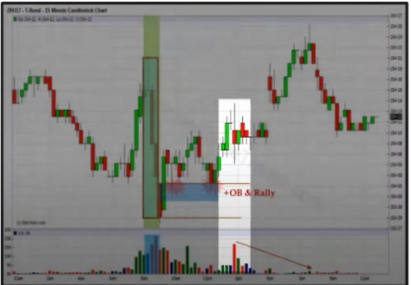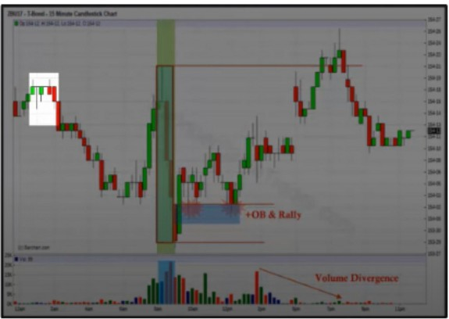

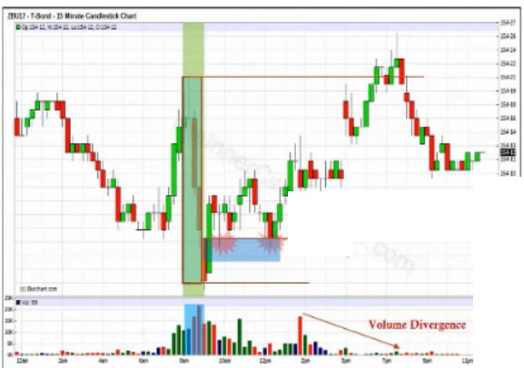

-

**+OBAl.all7**

Look for the bodies of the opening range but also incoorporate the wicks, and also look for previous highs and lows that are just to the left prior to 8am to 9am. Thats why ICT used the wick on the opening range at the top because its ran stops above a high to the left

Generally prefer opportunities at CME opening, 820am Its like trading the asian range

Bond market is the least manipulated market of them all

When FOMC or NFP comes then the bonds dont really make sense so just stay out at that time In general every market you dont want to trade around FOMC or NFP

When the bonds are trending its really clean

The bond generally doesnt have a large daily range

ICT would go back to trading bonds if forex would ever be gone or something

Even if you dont want to trade the bond market, this will still increase your price action understanding

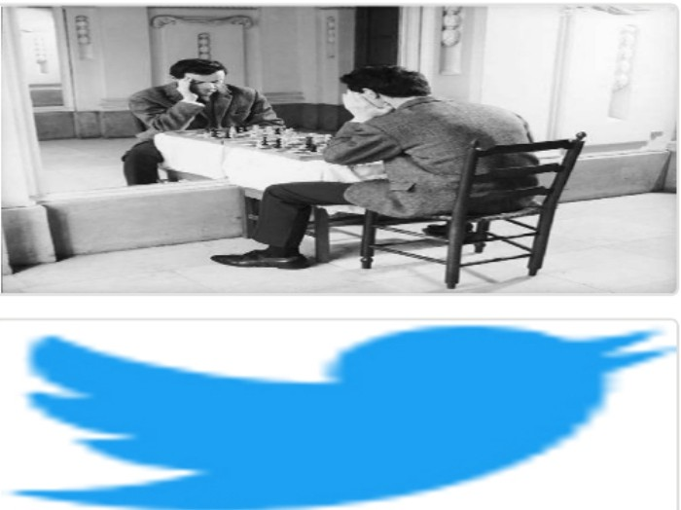Arjo I Twitter, lnstagram I Linktree

Linktree. Make your link do more. https://t.co/HhmmTN1fUI

JavaScript is not available.

***"JI*** https://twitter.com/arjoio